TNSKILLS PROJECT
LegalEase

Project Documentation
Introduction
Project Title: LegalEase: AI-Powered Legal Document Generator
Team ID:SWTID-2026-4532
Team Size:5
Team Leader : SUNANTHA S – Developer
Mail id: sunanthasakthivel200767@gmail.com
Team Members:
1.Sowmiya Akthar A S - Coding 1
Mail id: sowmiyaakthar@gmail.com
2 .Subashini K – Coding 2
Mail id: suba14@gmail.com
3. Subathra S – Demo video
Mail id: subathrasenthilkumar0@gmail.com
4. Swedha V – Document
Mail id: swedhavel30@gmail.com

LegalEase: AI-Powered Legal Document Generator
Project Description
LegalEase uses Generative AI to simplify the creation of legal documents through customizable, accurate and editable templates. It supports employment contracts, lease agreements, NDAs and other documents using inputs such as parties, effective dates and key terms.
• FastAPI backend with an AI core.
• Editable previews and automatic term tables.
• Custom branding such as logos and fonts.
• Export options: PDF, DOCX and TXT.
• Designed for entrepreneurs, professionals and individuals without a legal background.
Scenarios
• Startup founder – Employment Contract.
• Freelancer – Non-Disclosure Agreement. • Landlord – Residential Lease Agreement
Pre-requisites and Project Workflow
Pre-requisites
- FastAPI Framework Knowledge: FastAPI Documentation
- Google Gemini API Familiarity: Google Generative AI Documentation
- Streamlit for Frontend: Streamlit Documentation
- Python Programming Proficiency: Python Official Docs
- Environment Setup: pip install fastapi uvicorn streamlit python-docx fpdf Pillow requests google-generativeai python-dotenv
Project Workflow
• Activity 1: Model Selection and System Architecture.
• Activity 2: Core Functionalities Development.
• Activity 3: main.py & API Logic.
• Activity 4: Frontend with Streamlit.
• Activity 5: Deployment.
• Activity 6: Conclusion – finalize and test.
The workflow connects user input, FastAPI, Gemini generation, preview/editing and document export.
Milestone 1 – Model Selection and Architecture
Activity 1.1: Research and Select the Appropriate Generative AI Model
• Understand requirements: document type, parties involved, terms and conditions, effective dates.
• Review Gemini model documentation.
• Selected model: gemini-1.5-pro.
• Highlighted capabilities: long context window, structured prompting and fast generation.
• Used for formal documents, sections, legal terminology and dynamic clauses.
Activity 1.2: Define the Architecture
• Frontend: Streamlit.
• Backend: FastAPI.
• AI Core: Gemini integration.
• Formatting Modules: DOCX, PDF and TXT generators.
1.Architectural Diagram
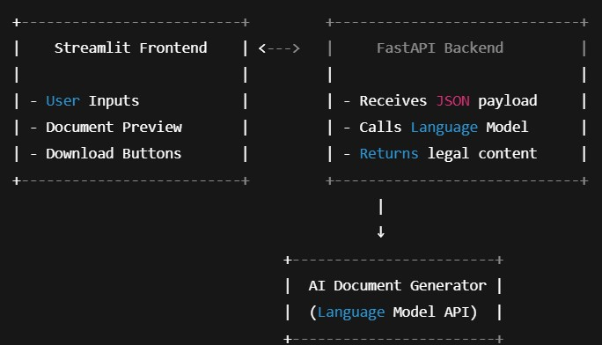

Milestone 1 – Frontend, Backend and AI Integration
Frontend Functionality
• TextInput for document type and dates.
• TextArea for parties and terms.
• Generate Document. • Edit Document.
• Download as TXT / DOCX / PDF.
• Styled HTML preview.
Backend Responsibilities
• POST /generate endpoint.
• Accept document_type, parties, terms and dates.
• Route to GeminiDocumentGenerator.
• Return structured document text.
AI Integration
GeminiDocumentGenerator forms a structured prompt, sends it through generate_content, receives generated text and returns it to FastAPI.

Activity 1.3 – Development Environment

Setup

• Install Python 3.10+ and pip.
• Create a virtual environment.
• Install FastAPI and Uvicorn.
• Install Streamlit.
• Install Google Generative AI SDK.
• Install python-docx, fpdf, Pillow, requests and python-dotenv.
• Set up the application structure
• Use .env for the Gemini API key.

Important Commands

pip install fastapi uvicorn
pip install streamlit
pip install google-generativeai
pip install python-docx fpdf Pillow requests python-dotenv
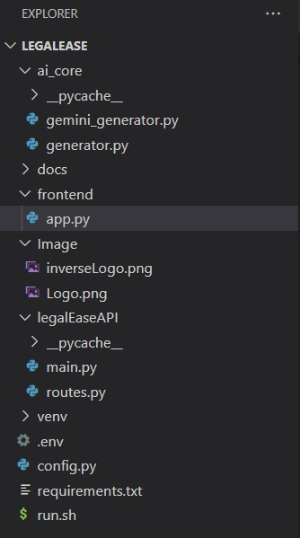

MILESTONE 2: Core Functionalities Development

Activity 2.1: Develop the core functionalities
- Legal Document Generation
Functionality: Generate legal documents (e.g., contracts, agreements) based on user inputs (document type, parties, terms, and dates).
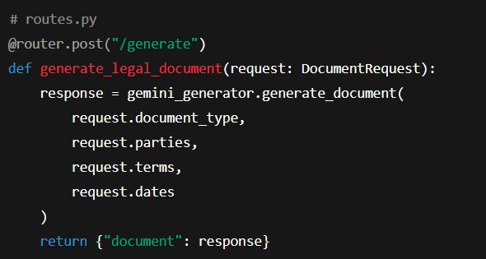
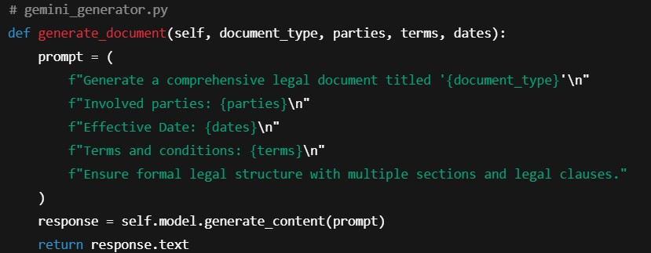
- Document Output Formatting
Functionality: Convert raw AI-generated text into structured .docx, .pdf, .txt files with legal formatting, logos, tables, and footers.

  - format_docx(text, doc_type)
  - format_pdf(text, doc_type)
  - format_html_preview(text)

These use:
  - docx for Microsoft Word formatting (includes logo, Times New Roman font, terms as table, footer).
  - fpdf for clean, branded PDF documents with headers/footers.
  - HTML Preview with Streamlit styling.

- User Interaction & Recommendations
Functionality: Accept user preferences through the Streamlit interface and reflect them in the AI-generated legal content.
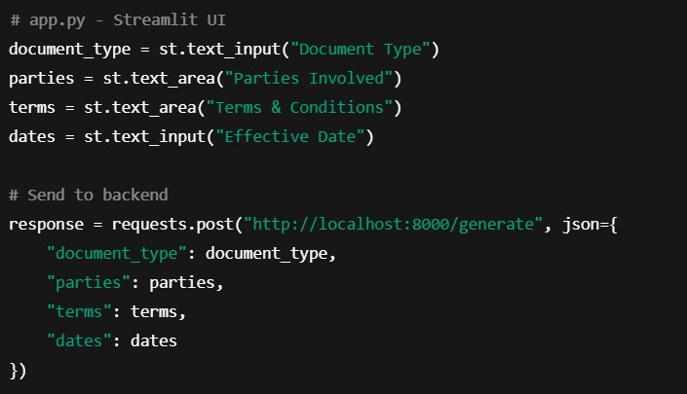

- Editable Document & Download
Functionality: Provides editable text area, allows download in .txt, .docx, .pdf formats.
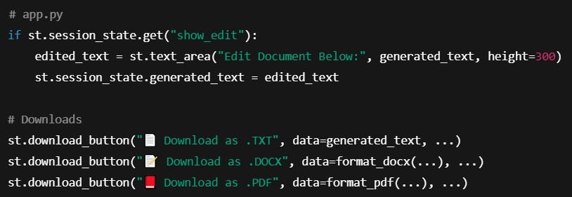

Activity 2.2: Implement the FastAPI Backend
- Define Routes in FastAPI (Instead of Flask)
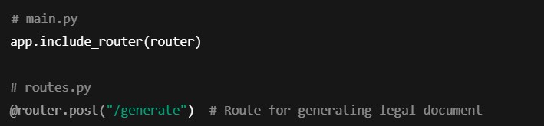
- Process User Input
Handled via Pydantic & Streamlit Forms:
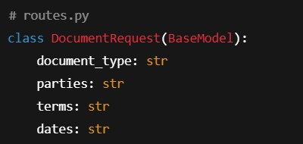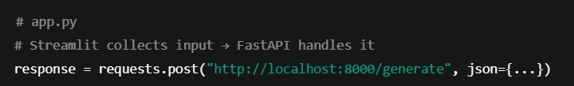

- Integrate Groq (Gemini) API Calls
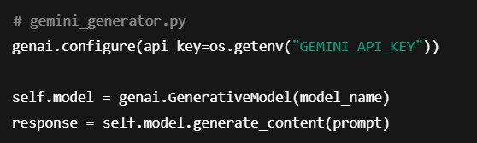

MILESTONE 3: API Logic Integration
In Milestone 3, the focus shifts to designing and integrating the backend API logic that powers document generation using the Gemini 1.5 Pro model.

Activity 3.1: Create and Configure main.py
This step involves initializing the FastAPI application, setting up the base endpoint for health-checks, and including modular API routes.
Steps:
  - Initialize the FastAPI app
  - Define a root (/) endpoint to verify the service is running
  - Include routes from the routes.py module
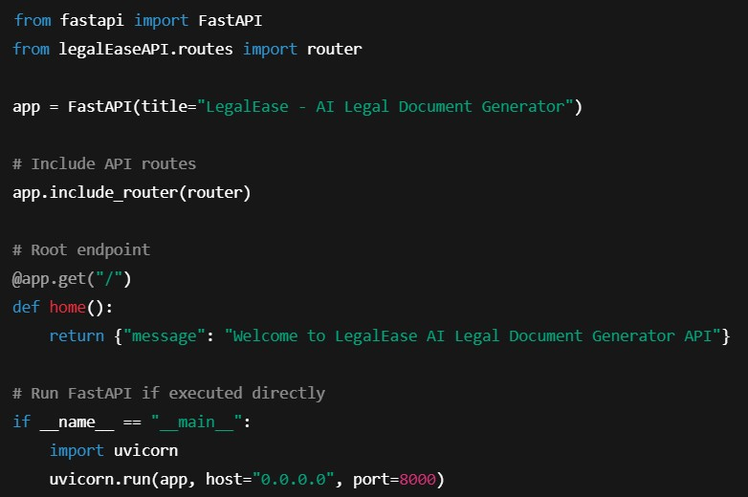
Activity 3.2: Handle Document Generation Logic in routes.py
This task handles user inputs from the frontend and sends them to the Gemini model for document generation.
Steps:
  - Define a Pydantic DocumentRequest model to validate incoming data.
  - Initialize the GeminiDocumentGenerator from ai_core.gemini_generator.
  - Create a POST endpoint (/generate) to accept user input and return generated legal content
  - . 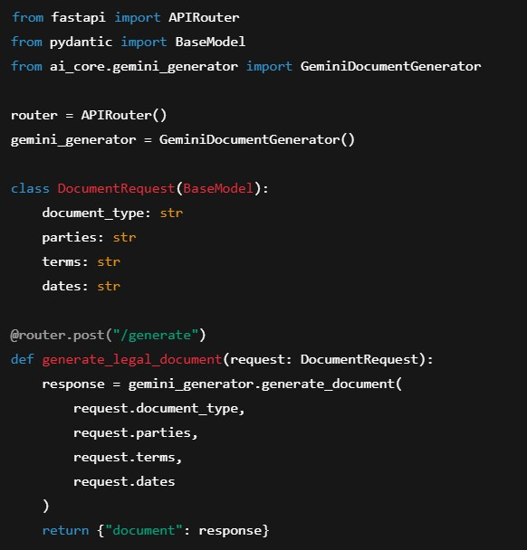

MILESTONE 4: Frontend Development – LegalEase
Milestone 4 focuses on creating a responsive and user-centric web interface for LegalEase using Streamlit.

Activity 4.1: Designing and Developing the User Interface
Step 1: Streamlit Page Configuration and Layout Setup • Configured Streamlit app with:
  - Added a three-column layout using st.columns to center-align the company logo
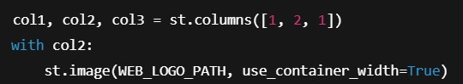
Step 2: Header and Title
  - Displayed a subtle center-aligned title under the logo:
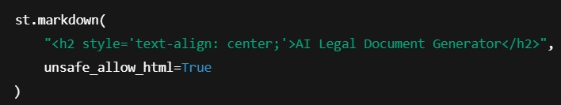
Step 3: User Input Interface
  - Created intuitive inputs for:
    - document_type: type of legal document o parties: involved stakeholders o terms: semicolon-separated clauses o dates: effective date
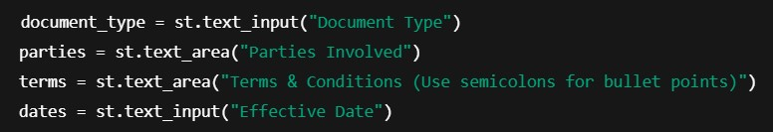
Activity 4.2: Creating Dynamic Previews and Export Options
Step 1: Generate Document with Backend AI
  - On clicking "Generate Document", a POST request is sent to the FastAPI backend:
  - AI-generated content is sanitized and displayed dynamically:
Step 2: HTML Preview Rendering
  - The output is previewed in an elegant dark-themed scrollable card with semantic HTML:

Step 3: Editable Document Preview
  - The user can click "Edit Document" and modify the generated content using a text area:
Step 4: Multi-Format Download Options
  - Users can download the document as:
    - .txt (Plain Text)
    - .docx (Formatted Word Document with logo, headings, and table) o .pdf (Branded PDF with logo and footer)

Core Functions & Utilities sanitize_text(text)
  - Removes special characters and typographic quotes to ensure clean formatting.
format_docx(text, doc_type)
  - Uses python-docx to:
    - Embed logo
    - Add titles, paragraph formatting
    - Auto-generate a Terms table from semicolon-separated input
format_pdf(text, doc_type)
  - Utilizes FPDF with custom header/footer:
    - Center-aligned logo o Bold headings for sections o Bullet-style terms
format_html_preview(text)
  - Converts output to stylized HTML blocks for inline display.

MILESTONE 5: Deployment
In Milestone 5, the focus is on deploying the LegalEase application locally using FastAPI as the backend and Streamlit as the frontend.
___________________________________________________________________________
Activity 5.1: Preparing the Application for Local Deployment
Step 1: Set Up a Virtual Environment
To ensure environment isolation and consistent dependency management, create and activate a virtual environment:
Step 2: Install Dependencies
Ensure that the backend (FastAPI) and frontend (Streamlit) dependencies are installed from a requirements.txt: pip install -r requirements.txt
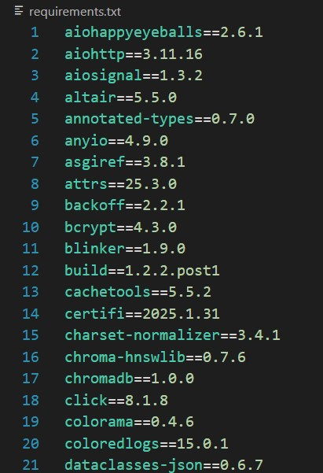
Step 3: Configure Environment Variables
Create a .env file to securely store your Gemini API key

Activity 5.2: Testing and Verifying Local Deployment
Step 1: Launch the FastAPI Backend
Start the backend server using Uvicorn:
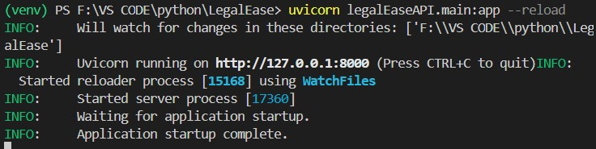

Step 2: Launch the Streamlit Frontend
Run the app.py file to start the LegalEase UI:
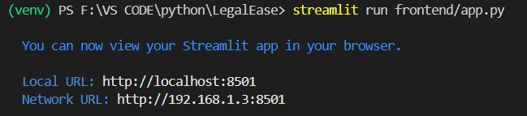
Step 3: Test All Functionalities
- Input document type, parties, terms, and date.
- Press Generate Document to get AI-generated legal content from Gemini.
- Use built-in options to: o Preview in dark mode HTML
  - Edit the text
  - Download in .txt, .docx, and .pdf formats • Check for:
  - Proper layout with logo and footer o Clean formatting of bullet points o Correct embedding of terms in the document

Exploring LegalEase

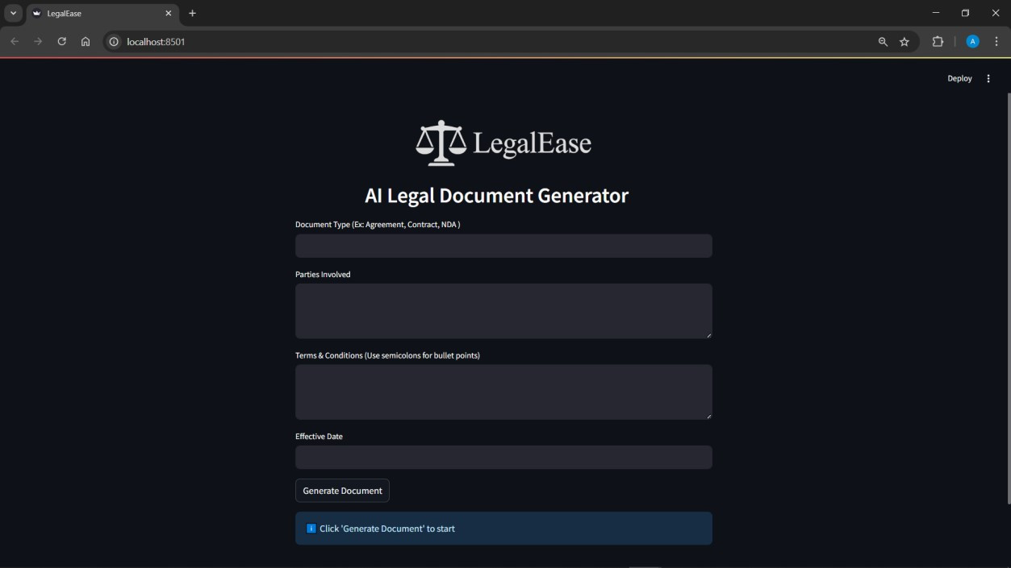
- Document Type
Purpose: Type of legal document to generate. Examples:
  - Agreement
  - Contract
  - NDA (Non-Disclosure Agreement)
  - Lease Agreement
  - Employment Offer Letter
Example input: Freelance Work Contract
- Parties Involved
Purpose: Names and roles of the individuals or entities involved in the document. Examples:
  - John Doe (Freelancer), ABC Corp (Client)
  - Alice Smith (Tenant), XYZ Realty (Landlord)
Example input: Jane Doe (Service Provider), TechNova Inc. (Client)

- Terms & Conditions (Use semicolons for bullet points)
Purpose: Specific clauses or rules that define the agreement. Separate each bullet point using a semicolon.
Examples:
  - Payment to be made within 30 days of invoice;
  - The provider agrees to deliver work by the agreed deadline;
  - Confidentiality must be maintained at all times;
  - Either party may terminate with 15 days notice
- Effective Date
Purpose: The date when the agreement becomes legally valid.
Examples:
  - April 10, 2025
  - 10/04/2025
  - April 15, 2025

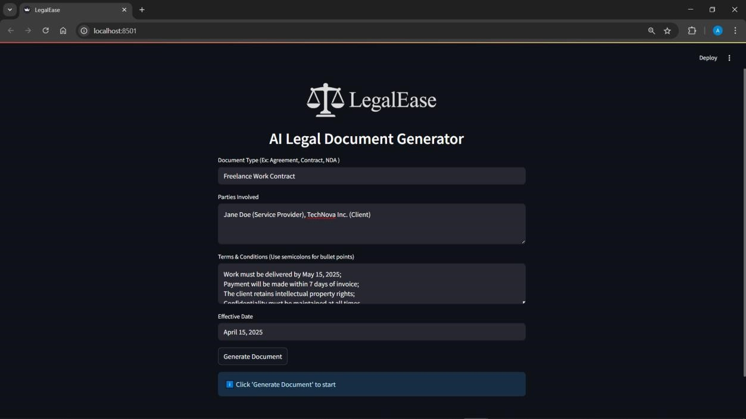

Document Generated
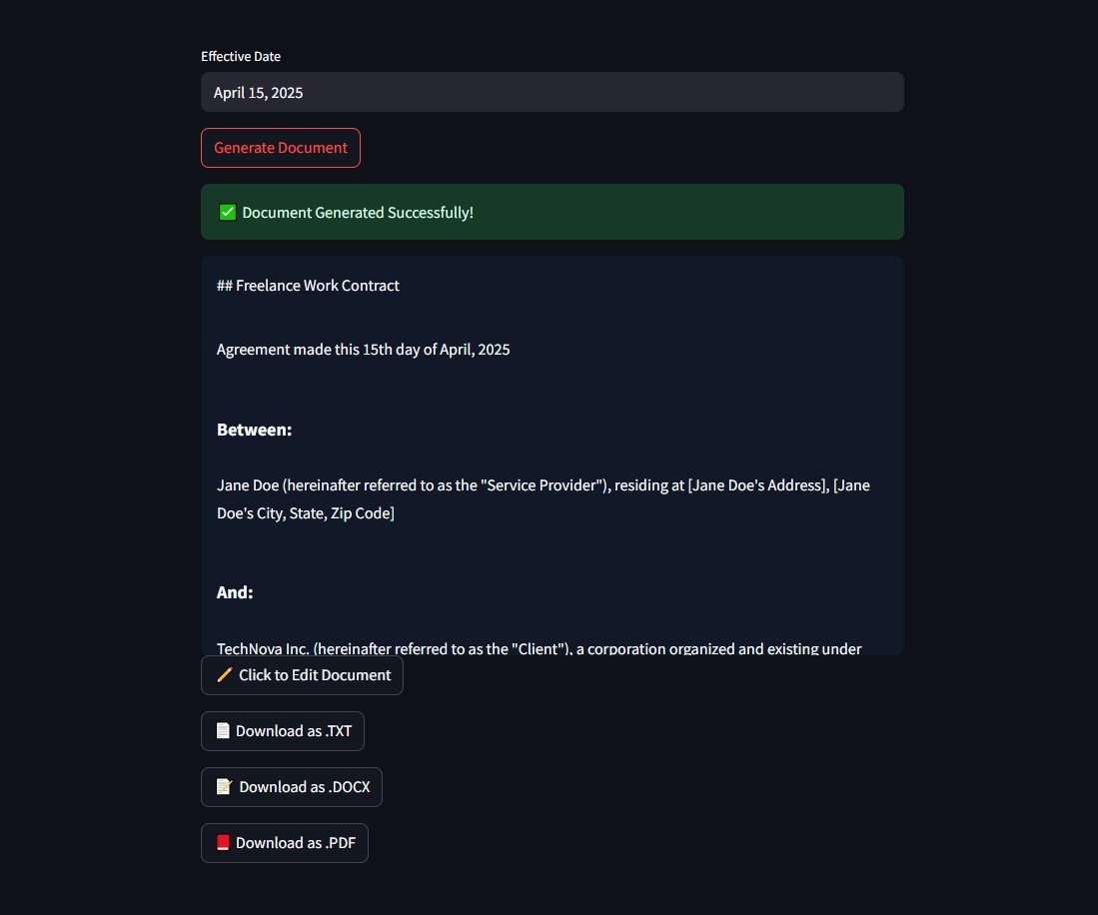
Editing the Document
If the user wants to edit the document, they can do so by clicking on the “ Click to Edit Document” Botton. A new window opens up where the document can be edited.
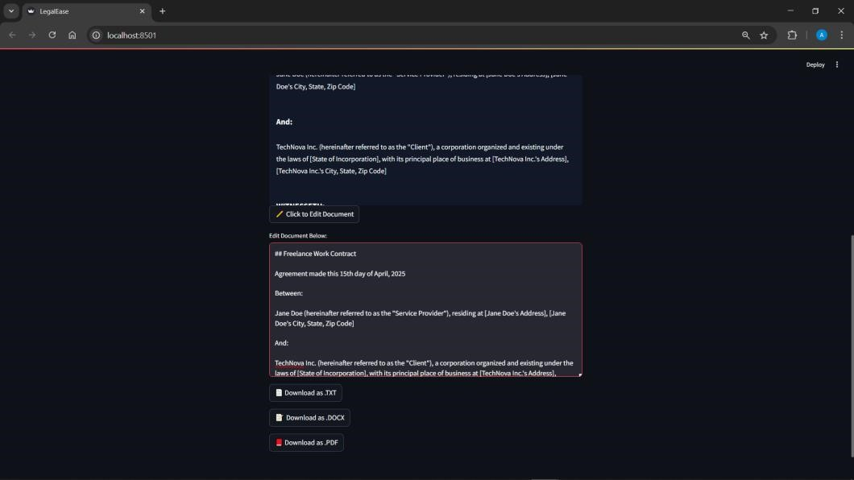

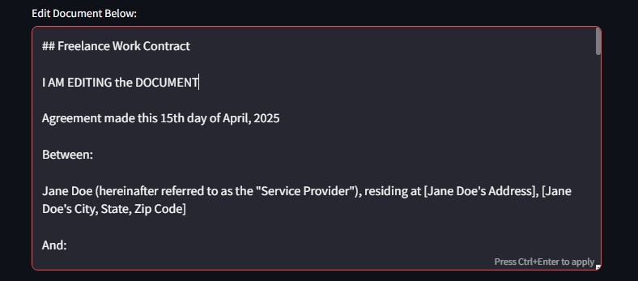
Downloading/ Saving the Generated Document
We can Download and save the documents in any of the following formats.
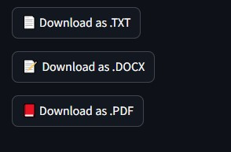
- .txt
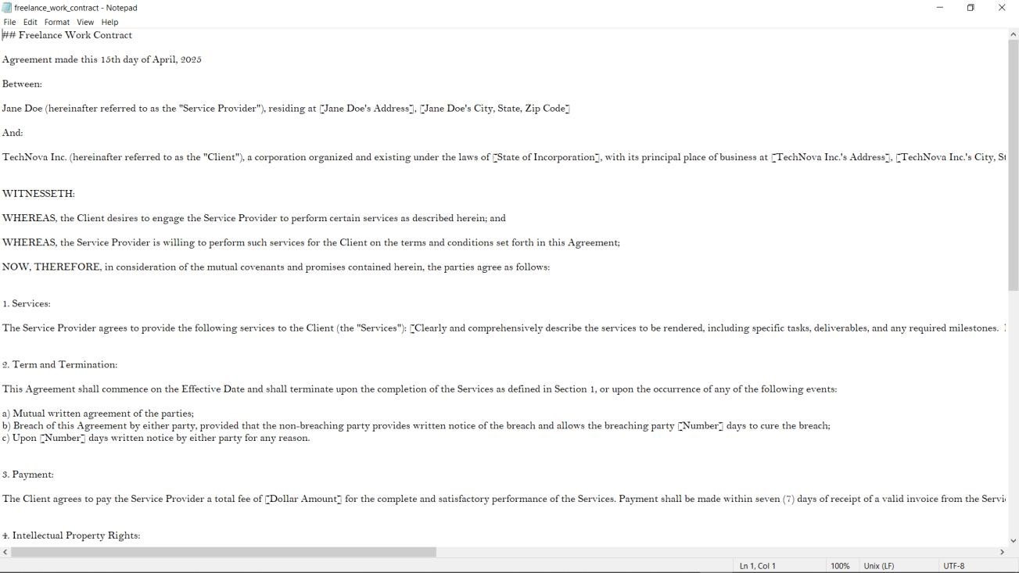
- .docx
The document provided inculcates the use of the logo (front page) as well as the footer in the last page

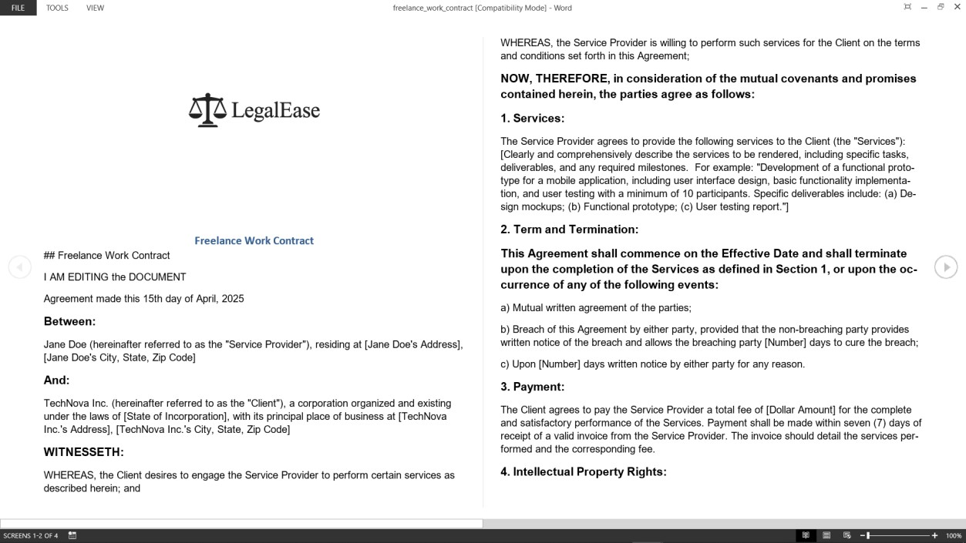
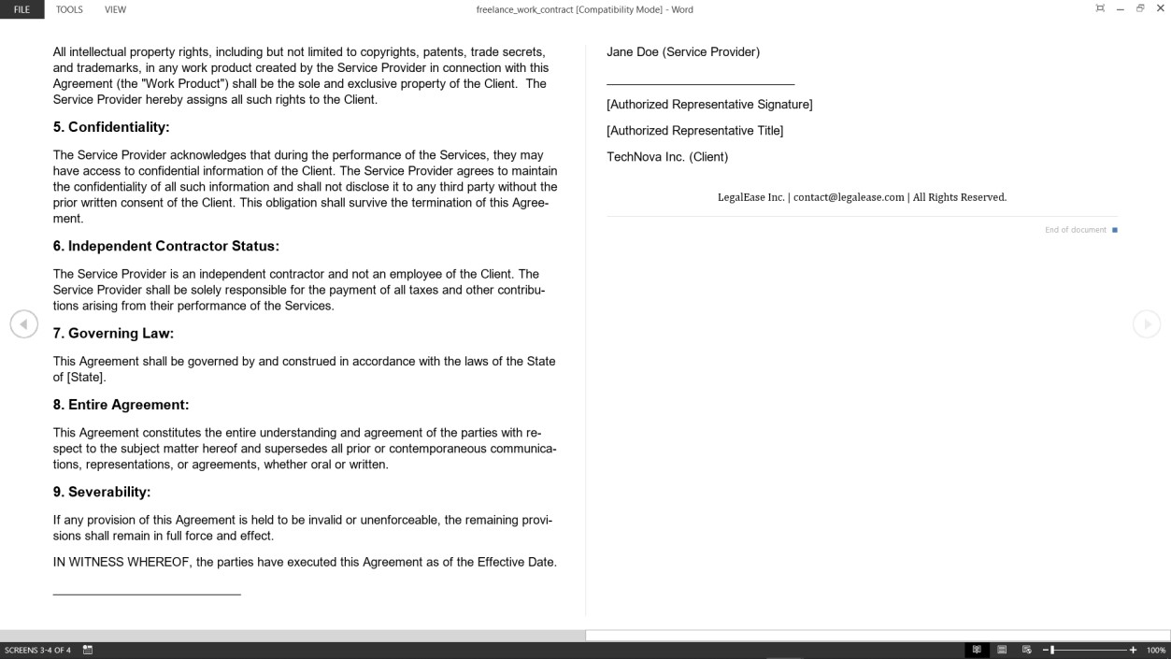

- .pdf
This format provided the user with a well formatted and ready to use legal document with Logo and Footer on all the pages.

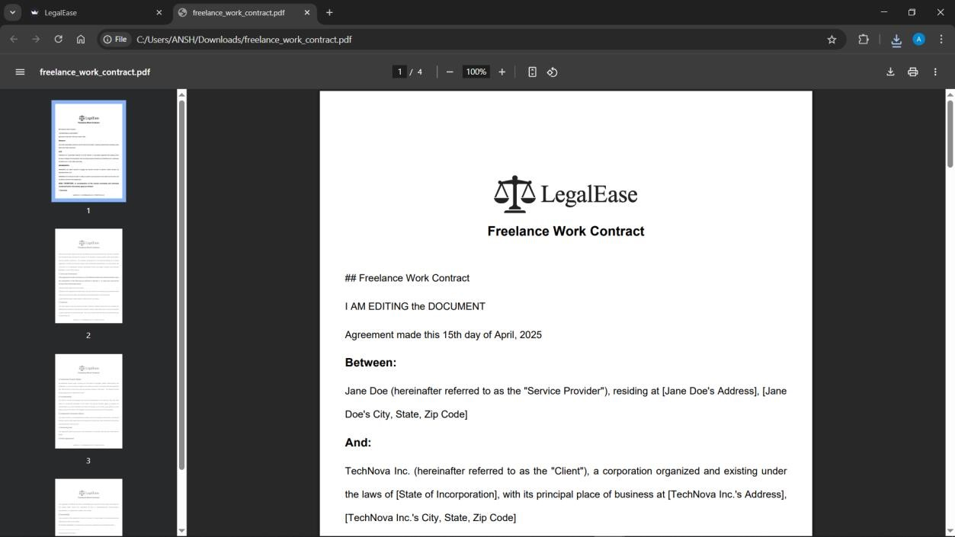
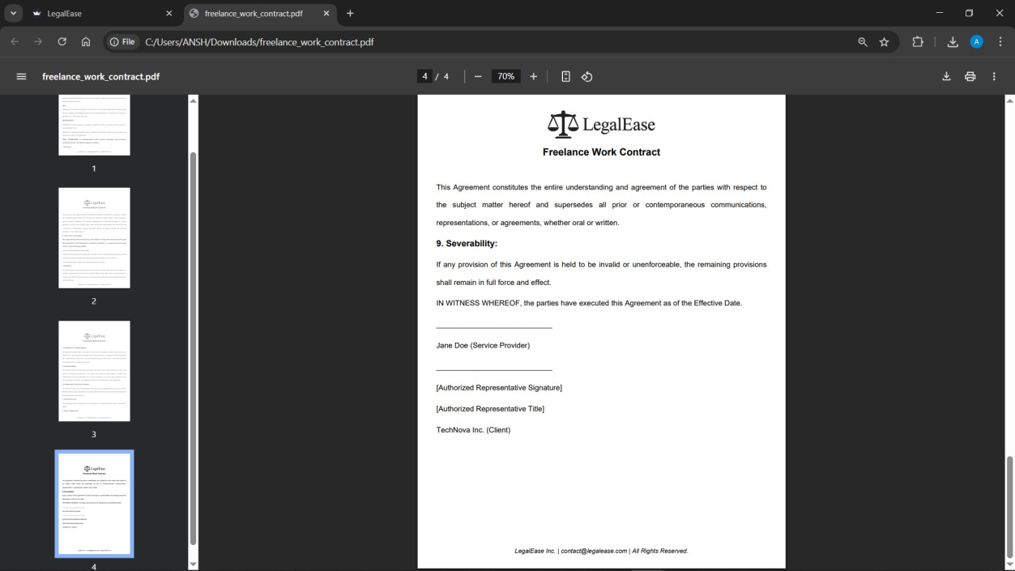

Conclusion
LegalEase represents a transformative step in bridging the accessibility gap in legal services through the power of artificial intelligence. This project demonstrates how emerging technologies can simplify complex legal language, providing users—regardless of legal background—with a clear, concise understanding of legal documents. By integrating advanced natural language processing (NLP) models with user-centric design, LegalEase empowers individuals to navigate legal content with confidence, thereby promoting inclusivity and informed decision-making.

